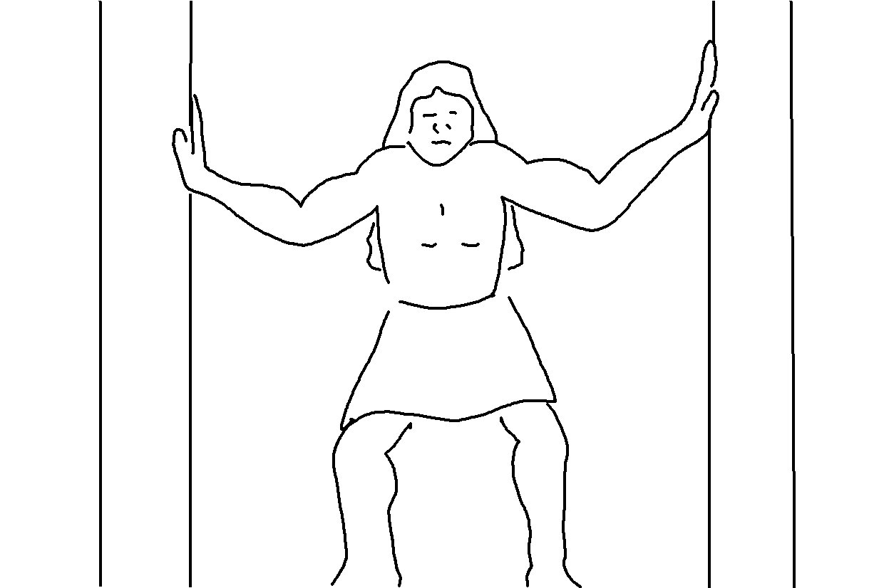
_ _ _ _ _ _ today whom you will serve… But as for me and my family, we will _ _ _ _ _ the _ _ _ _ _. Joshua 24:15_{NLT}

